Vocabulary.

Shops and other places (definitions)

**Read these definitions and choose the right variant.**

1. A shop where you can buy souvenirs:  
- Clothing shop  
- Gift shop

2. A shop where you can buy cloth, pins, thread, etc. used for sewing:  
- Ironmonger’s  
- Drapery

3. A shop that prepares and sells meat:  
- Butcher’s  
- Record shop

4. A shop where you can buy clothes:  
- Gift shop  
- Clothing shop  
  
5. A shop where you can buy chairs, tables, sofas and other things:  
- Furniture shop  
- Electronics shop

6. A shop where you can buy cheap, unusual things:  
- Gift shop  
- Novelty store

7. A shop where you can buy electronic things for home:  
- Drapery  
- Electronics shop

8. A shop where you can buy cheese, milk, cream:  
- Record shop  
- Dairy

Shops (definitions)

**Read these definitions and choose the right variant.**

1. A soft powder made from sugar that is used to make icing for cakes:  
- Confectioner’s  
- Thrift shop

2. A shop that sells old furniture and other things of little value:   
- Big-box store  
- Junk shop

3. A shop where you can buy leather goods:  
- Leather goods shop  
- Toyshop

4. A shop that sells cakes, etc.:  
- Patisserie  
- Coffee shop

5. A small shop, especially on a corner of a road, that sells foods and other things that are often needed:  
- Corner shop  
- Leather goods shop

6. A small shop with an open front or a table from which goods are sold:  
- Stall  
- Tearoom

7. A shop where you can buy toys :  
- Leather goods shop  
- Toyshop  
  
8. A table or a very small shop with an open front where books, magazines, etc. are sold:  
- Bookstall  
- Thrift shop

Shopping terms (definitions)

**Read these definitions and choose the correct variant.**

1. A machine, usually in a wall outside a bank, from which you can take money out of your bank account using a special card:  
- Cash dispenser  
- Cash card

2. A large shop where people, usually from another business, can buy large amounts of goods cheaply and take them away immediately:  
- Cash-and-carry  
- Mall

3. A shop that sells newspapers, magazines, and things like sweets and cigarettes:  
- Bakery  
- Newspaper stand

4. A shop where you can buy drugs, soap, beauty products, etc:  
- Chemist‘s  
- Petrol station

5. A shop where you can buy bread, cakes, etc:  
- Cash-and-carry  
- Bakery

6. An occasion when people sell things, often in their garage or outside their house, that they no longer want:  
- Haberdashery  
- Garage sale

7. A market where you can buy old or used things cheaply:  
- Flea market  
- Mall

8. Cloth, pins, thread, etc. used for sewing, or a shop or a department of a large store that sells these:  
- Newspaper stand  
- Haberdashery

Reading.

Shops in Britain

**Read the text "Shops in Britain".**

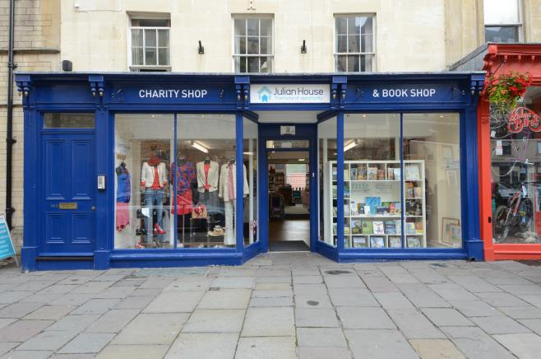

In all big cities of Great Britain there are a lot of department stores. They are big shops where you can find almost everything you want and which offer a wide choice of things. The most famous British department store, Harrods, started as a small grocery shop in 1849. The present store has more than 300 departments and a staff of over 4,000 people. The display in the food hall is amazing. For example, there is a choice of over 500 types of cheese.

Street markets are both fun and cheap. Most markets sell fruit and vegetables, clothes, things for the house, records and jewellery. In London there are about 40 or 50 markets. Some specialize in flowers, pets or secondhand books.

In the centre of most towns and villages there is a main street with lots of different shops. This street is usually called the High Street. The high streets of Britain are beginning to look more and more the same. This is because they are full of branches of big chain stores.

One of the best-known chain stores is Marks & Spencer, which sells clothes and food. The company has over 700 stores worldwide and has a reputation for good quality. If you buy something that you decide you don’t like, you can take it back and get your money back.

Some towns are called market towns: a market is held there, usually once a week. People come from the surrounding villages to do shopping there.

Eighty-seven per cent of British people live less than a mile from their local corner shop. A corner shop is a small shop on, or near, a street corner. Only in corner shops do shopkeepers know their customers personally. Only in them is the interaction across the counter often social as well as transactional. Many corner shops are run by Indian or Pakistan families. Most corner shops sell food and newspapers. They are open until late in the evening, as well as on Sundays.

However, many small high-street and corner shops are closing because people prefer to drive to a shopping complex outside town. There they can park their cars without any problems and do all the shopping in one place.

In a British shopping complex you usually find a supermarket, a branch of most of the chain stores, some smaller shops, a few cafes and sometimes a multiscreen cinema. Most of the new shopping complexes are built near big roads, outside town.

Here you also find “superstores”. These enormous shops sell their products more cheaply than in the high-street shops. Many of the superstores are branches of chain stores from countries outside Britain, such as IKEA or Aldi. However, this trend has not gone as far as it has in some other European countries.

The normal time for shops to open is nine in the morning. Most small shops take a break for lunch, usually between one and two, and then close at half past five or a bit later. Large out of own supermarkets stay open all day until about eight o’clock.

**Write four words into each gap.**

1. If you buy something that you decide you don’t like, you ____________ and get your money back.

2. However, many small high-street and _____________ because people prefer to drive to a shopping complex outside town.

3. In a British shopping complex you  _____________  , a branch of most of the chain stores, some smaller shops, a few cafes and sometimes a multiscreen cinema.

4. The company has over 700 stores worldwide and has _______  quality.

5. However, this _____________ as far as it has in some other European countries.

6. Only in them is the _____________ often social as well as transactional.

7. In a British shopping complex you ____________  , a branch of most of the chain stores, some smaller shops, a few cafes and sometimes a multiscreen cinema.

Supermarkets

**Read the text "Supermarkets".**

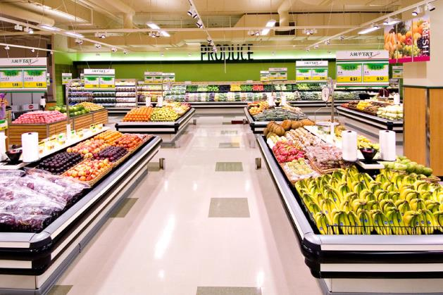

I love shopping. I like looking around the shops and buying things. There is a very good supermarket near my house. It has got everything you need. If you want a tin of fish, a box of chocolate, a tube of toothpaste, a bottle of beer, a carton of milk or a jar of jam - you will find it there.

If I buy a lot of things, I usually use a trolley. If I don’t want much, I just take a basket and look for the things I want. Sometimes, I can’t find things on the shelves and I ask an assistant to help me. When I see what I want, I just take it from the shelf and put it into my trolley or basket.

When I have everything I need, I go to the check-out and stand in a queue. To pay for the things I have in my trolley or basket, I give money to the cashier. The cashier takes my money, puts it  into the till and gives me my change. If the customers are not happy with the service or there is something wrong, they can complain to the manager.

**Write two words into each gap.**

1. If I buy a lot of things, I usually use ______________ .

2. Sometimes, I can’t  _____________ on the shelves and I ask assistant to help me.

3. To pay for the things I have in my trolley or basket, I give money to  ___________ .

4. It has ____________ you need.

5. When I have everything I need, I go to the check-out and  ____________  a queue.

6. If the _________ not happy with the service or there is something wrong, they can complain to the manager.

Shopping

**Read the text "Shopping".**

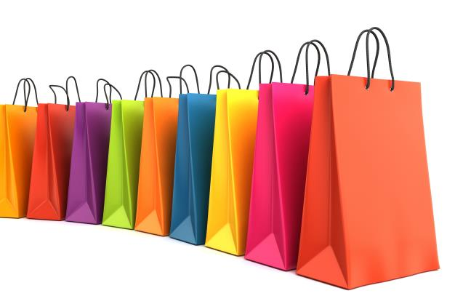

When we want to buy something, we go to a shop. There are many kinds of shops in every town or city, but most of them have a food supermarket, a department store, men's and women's clothing stores, grocery, a bakery and a butchery.

I like to do my shopping at big department stores and supermarkets. They sell various goods under one roof and this is very convenient. A department store, for example, true to its name, is composed of many departments: ready-made clothes, fabrics, shoes, sports goods, toys, china and glass, electric appliances, cosmetics, linen, curtains, cameras, records, etc. You can buy everything you like there.

There are also escalators in big stores which take customers to different floors. The things for sale are on the counters so that they can be easily seen. In the women's clothing department you can find dresses, costumes, blouses, skirts, coats, beautiful underwear and many other things. In the men's clothing department you can choose suits, trousers, overcoats, ties, etc. In the knitwear department one can buy sweaters, cardigans, short-sleeved and long-sleeved pullovers, woolen jackets. In the perfumery they sell face cream and powder, lipstick, lotions and shampoos.

In a food supermarket we can also buy many different things at once: sausages, fish, sugar, macaroni, flour, cereals, tea. At the butcher's there is a wide choice of meat and poultry. At the bakery you buy brown and white bread, rolls, biscuits. Another shop we frequently go to is the greengrocery which is stocked by cabbage, potatoes, onions, cucumbers, carrots, beetroots, green peas and what not. Everything is sold here ready-weighed and packed. If you call round at a dairy you can buy milk, cream, cheese, butter and many other products.

The methods of shopping may vary. It may be a self-service shop where the customer goes from counter to counter selecting and putting into a basket what he wishes to buy. Then he takes the basket to the check-out counter, where the prices of the purchases are added up. If it is not a self-service shop, and most small shops are not, the shop assistant helps the customer in finding what he wants. You pay money to the cashier and he gives you back the change.

**Write *true* or *false.***

1. The author likes to do shopping in corner shops.

2. The author says that in a dairy you can buy milk, cream, cheese, butter and many other products.

3. The shop assistant helps the customer in finding what he wants.

4. The author says that in the men's clothing department you can choose toys, trousers, overcoats and sweets.

5. The methods of shopping may be different.

7. The author likes to do shopping at big department stores and supermarkets.

8. The author says that in a food supermarket you can buy pets, clothes, sweets.

Smart shopping

**Read the text "Smart shopping".**

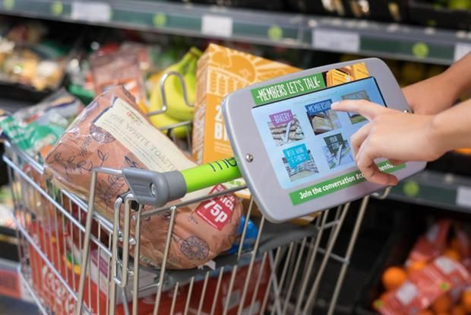

As the festive period approaches, more and more customers are expected to go shopping with their tablet or smartphone. Many people plan to use their devices to locate stores, compare prices and make purchases.  Nearly half of consumers in the U.S admit to showrooming. This is when customers visit a store to see and touch products and then order them on-line, often at a cheaper price. To combat this, smart retailers are offering discounts and allowing customers to order on-line and pick up their goods in store. Nevertheless, in the US, 40 % of shopping happens while people are sitting on the couch in front of the TV, or even in bed.

**Write *correct* or *incorrect.***

1. Many people plan to use their devices to locate stores, compare prices.

2. Showroom is a place where you can see and touch products and order them on-line.

3. 40 % of shopping happens while people are at work.

4. More and more customers are expected to go shopping with their tablet or smartphone.

5. Nevertheless, in the US, 50 % of shopping happens while people are sitting on the couch in front of the TV, or even in bed.

6. Nearly half of consumers in the U.S admit to showrooming.

7. Smart retailers are offering discounts.

Definitions.

Shops around us

**Write the word for each definition.**

1. A shop where you can buy boots, sandals, trainers and other types of shoes

2. A shop where you can buy pistols and other types of guns

3. A place where you can buy stamps and send letters and parcels

4. A shop where you can have your eyes tested and have your glasses made

5. The place where you go to have your hair washed, cut, coloured, etc

6. A place that sells things for gardens such as plants and tools

7. A store that sells food and sometimes other goods, but is not as big as a supermarket

8. A shop where you can buy liquids with a pleasant smell that women or men put on their skin

9. A shop that sells fish

10. A shop where a barber works